**Assignment**

**MODULE: 1 SE – Overview of IT Industry**

**Q1. What is software? What is software engineering?**

**Ans. SOFTWARE -** It is a collection of computer programs and related data that provide the instructions for telling a computer what to do and how to do it.

**Software Engineering -** is a systematic approach to the design, development, operation, and maintenance of a software system.

**Q2. Explain types of software**

**Ans.**  **1. System Software –** it provides the basic functions for computer usage and helps to run the computer hardware and system. is the s/w used by the computer to translate inputs from various sources into a language which a machine can understand. Basically, OS coordinates the different hardware components of a computer. Ex. Linux, window, macOS, Android, iOS.

**2.** **Application Software -** is the general designation of computer programs for performing user tasks. Types of application software are:

a) Mobile app

b) Desktop app

c) Web app

**3. Programming Software -** is the process of designing, writing, testing, debugging, and maintaining the source code of computer programs. The purpose of programming is to create a program that exhibits a certain desired behavior. Ex. c++, html, java, Simlab, php, Python and Visual basic.

**Q3. What is SDLC? Explain each phase of SDLC**

**Ans.** A software life cycle model (also termed process model) is a pictorial and diagrammatic representation of the software life cycle. A life cycle model represents all the methods required to make a software product transit through its life cycle stages. It also captures the structure in which these methods are to be undertaken.

1. Requirements Gathering - Requirement analysis is the most important and fundamental stage in SDLC. It is performed by the senior members of the team with inputs from the customer, the sales department, market surveys and domain experts in the industry.
2. Analysis - Once the requirement analysis is done, the next stage is to certainly represent and document the software requirements and get them accepted from the project stakeholders.
3. Design - The next phase is about to bring down all the knowledge of requirements, analysis, and design of the software project. This phase is the product of the last two, like inputs from the customer and requirement gathering.
4. Implementation - In this phase of SDLC, the actual development begins, and the programming is built. The implementation of design begins concerning writing code. Developers have to follow the coding guidelines described by their management and programming tools like compilers, interpreters, debuggers, etc. are used to develop and implement the code.
5. Testing - After the code is generated, it is tested against the requirements to make sure that the products are solving the needs addressed and gathered during the requirements stage. During this stage, unit testing, integration testing, system testing, acceptance testing are done.
6. Maintenance - Once when the client starts using the developed systems, then the real issues come up and requirements to be solved from time to time. This procedure where the care is taken for the developed product is known as maintenance.

**Q4. What is DFD? Create a DFD diagram on Flipkart**

**Ans.** A Data Flow Diagram (DFD) is a traditional way to visualize the information flows within a system. A neat and clear DFD can depict a good amount of the system requirements graphically. It can be manual, automated, or a combination of both. It shows how information enters and leaves the system, what changes the information and where information is stored. The purpose of a DFD is to show the scope and boundaries of a system as a whole.

**Q5. What is Flow chart? Create a flowchart to make addition of two numbers**

**Ans.** A flow chart is a graphical or symbolic representation of a process. Each step in the process is represented by a different symbol and contains a short description of the process step. The flow chart symbols are linked together with arrows showing the process flow direction.

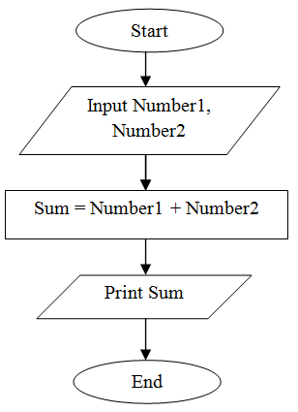

**Q6. What is Use case Diagram? Create a use-case on bill payment on paytm.**

**Ans.** A use case diagram is a dynamic or behavior diagram in UML. Use case diagrams model the functionality of a system using actors and use cases. Use cases are a set of actions, services, and functions that the system needs to perform.

